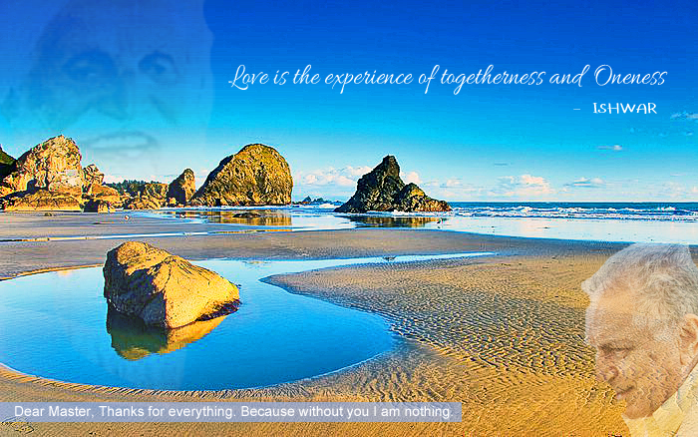
Spirituality is not a Religion
ISHWAR PURI: In this gathering we have people from not only the United States - from as far away as California in the West, from Dallas in the South, from Wisconsin in the North - but from several overseas countries, including Sweden, Germany, Austria, London, Iran, Iraq, Philippines, Japan, India, Ghana. So you will notice we are here from all over the world. Also in this gathering are Hindus, Muslims, Christians, Jews, Druze, and atheists. And they all are open to the same spiritual path that I share with you. The point I am making is spiritual path is not a religion. It is not meant for any particular religion. It's open to all religions. It's open to all nationalities. It does not care for caste, creed, nationality, gender. It's a universal thing and open to all human beings.
Every religion that I studied, and I studied eleven religions at Harvard University. Every religion talks of one God. And after the founders of religions, who were mystics and saints, who left these messages for us, we make them small groups and call them religions, societies, associations, missions. Masters don't come for setting up any religion. They don't come to set up missions, societies or any group. Their message is always for everybody. When Jesus said, “The kingdom of God is within you,” He did not mean the kingdom of God is within Christians. He meant within everybody. … The Hindu text says one God and all religions are covered by that. ... If you look at the recorded teachings of these people, they are saying openly their message is for all seekers of the entire world, of the entire humanity. After they have left, we have made them into small groups and called them religions, societies, missions. They don't come to set up missions. It's an exploration of your own self, of your own reality. How can there be different realities? Spirituality does not recognize any groups. Spirituality is for everybody.
I've never claimed to be a master. You know that. Why am I doing all this? As a service to my master. You might think I am doing your seva. No. That's incidental. I'm doing seva for him, strictly according to his instructions. … My master came for the whole world. I'm going to send his message to the whole world.
In 1936-37, Great Master wrote letters to several American disciples in which he said, “The axis of spirituality is going to shift to the West. There will be perfect living masters, a series of them in the West, in Europe, in America and specially in North America.” … People in the West are tired of affluence. It has not given them the peace of mind they wanted. It has not given them any spiritual benefit. It has only led to more struggle, more competition. And more unhappiness. Therefore, Great Master said, “One day India, China, these great Eastern countries where great mystics came, will be running after money, setting up more factories, more industries, trying to make more money. Whereas, the West which has been making money and doing industrial work, will turn to spirituality and look for something more real inside.” I'm just a witness to this change and very happy to be doing that. ...

(Following the talk, Babaji took up a few questions. This is just one of them.)
Question: I have a quest for spirituality, but being a young man, I also have an attraction for the opposite sex. Is that a problem for my spiritual growth?
Ishwar: As it happens, we all old folks have also been young men, including me. And we've all had the same problem. So it's not unique. In fact, it's one of the most significant problems. Sex is a natural function of the human body. It's a function that's been placed in us for reproduction. It's a function without which the whole population would not grow. The species won't grow. No species will grow. It's a natural function provided to human beings and all other species of life. It's not something unnatural. Therefore, it's a natural activity that will happen.
Now when you say will it come in your way, it depends upon how you look at it. If you look at it as something that's a temptation and something that's dragging you out, it will come like any other distraction. It will come in your way. If you take it as a natural activity, which is natural to human beings, it will not be a distraction. It all depends on how you take these things in stride. And not only sex, it's also all other activities in life.
People have asked me, “I have to go to my job and have to put my attention there. Is it a distraction in meditation and in my spiritual life?” My answer is, “If, when you are doing your job, you are thinking of master, it's master's job, an opportunity given by your master, it's as good as meditation.” These are not my words – Great Master's words. Everything you do should be done with the thought of the master and it becomes meditation. ...





We don't give up these things in the world just because we think they are a distraction and meditation is something separate. Meditation is not something separate from your life. Your entire life should be meditation. Everything you do should be with the thought of your master and spirituality and it becomes spiritual and meditation. These relationships here - sexual relationships, other relationships – they are created because of our karmas. We meet people because of our past actions in past lives. It's a natural law of karma that's creating these things. We have to go through them. You should take them as something that you are acting a role in a play and you are actors. That's not your reality. Your body is not your reality. Your body is an actor acting here. Whatever you are doing here is an act according to a play. Put your attention within and remember the master. Even if you are having sex, remember the master. Therefore, don't think the activities of this life – of any kind – are supposed to be taking you away from the spiritual path. You can do all your work of any kind, anywhere, and so long as you think you are doing it as master's work, it's like meditation. So don't be worried about these things.

